|  |
| --- |
| CUNY SPS: Masters in Science of Data Science |
| Simulation Analysis: Hotel Management and Efficient Staffing Models |
| DATA604: Simulation and Modeling Techniques |

|  |
| --- |
| Chris G Martin  12-4-2017 |

Contents

Purpose 2

In-Scope 3

Out-of-Scope 4

Other Notes and Assumptions 5

Structure / Process Diagram 5

Random Time Estimates Used 7

Costs and Revenues Used 8

Staff Scheduling Used 8

Verification and Validation 9

Min/Max Profit Range 9

Verification Checks 9

Validation Checks 10

Statistical Model 11

Simulation Models 11

Shared Properties 11

Model 1: On-Demand Housekeeping 12

Model 2: Roaming Housekeepers 12

Comparison of Results via Statistical Methods 13

Conclusions from the Modeling 13

Lessons Learned 14

Additional Resources 15

References 16

Final Project Prompt 18

Purpose

The aim of this project is to use simulation analysis to analyze the efficiency and effectiveness of a hotel by using simulation analysis and statistical analysis. Simio, a dynamic simulation tool, is used to run the simulation, with the results compared against statistical models run in R using RStudio for reproduction.

The theoretical hotel in this simulation has 32 rooms, 7 rooms are premium rooms and the remaining 25 rooms are standard rooms. Rooms are booked in-person by single guests who pay by the hour, with premium guests staying in the premium rooms (with exceptions described) and standard guests staying in the standard rooms, only. The arrival of these guests are random (with all boundaries described in the preceding sections), with receptionists to check in the guests, porters/bellboys to escort the guests in and out of the room, and housekeepers to clean vacant rooms after guests leave.

In terms of efficiency, the hotel will keep a close eye on the utilization of resources (rooms and employees). A key driver to this aspect is the number and the schedule of housekeepers, porters, and receptionists.

In terms of effectiveness, the key metric that will be the focus of the simulation is revenue. Rates for guests are standardized based on the room being utilized, and costs are determined by a flat (fixed) rate for rooms and hourly rates for active employees.

While the pros and cons of simulation modeling, and the differences between numerical solutions and simulation models, in the hospitality industry have been well documented and are well studied [1], this is not the focus of this project. Nor, is the focus of the project on the benefits of simulation in hospitality [2], [3] (though interesting as it may be). The focus of this project is the simulation itself, not the theory or principals of simulation modeling.

All models are saved in GitHub and can be found in the Additional Resources section at the end of this document.

## In-Scope

The scope of this project includes:

* Three different types of staff will be included in the model:
  + Housekeeping: these resources are responsible for cleaning rooms.
  + Reception: this resource is simply a server who is responsible for checking customers into their room.
  + Porter/Bellboy: these resources escort guests to and from their room.
* Two different room and guest types will be included in the model:
  + Standard Rooms: standard rooms hosts standard guests (and in special instances, premium guests). The standard room rate is used regardless of guest type.
  + Premium Rooms: premium rooms host premium guests, with premium guests at a premium rate.
  + If a premium guest wants to check into a room but there are no premium rooms available, a standard room will be used at the standard rate.
  + If a standard guest wants to check into a room but there are no more standard rooms available, a premium room will not be used. This ensures the hotel maintains the premium status on the room, despite the loss of revenue.
* Costs and revenues:
  + Costs are hourly expenses for salaries to the active resources, fixed expenses on the rooms (which includes cleaning supplies)
  + Revenues are based on hourly rates of rooms between guest check-in and check-out.

## Out-of-Scope

Not included in this project:

* Daily variances: the simulation is run for a single day at a time, so this model is not based on a busy day, rush day, slow day, or average day. Each day is a random day. Busy periods and holidays require a different model.
* Free moving objects, or objects moving in free space: objects / entities will follow paths, which is not exactly life-like but the addition of random speeds for entities (i.e. some housecleaners are faster than others) should offset some of the variance.
* Unique instances for staff members (note, staff will not be cross-trained, they will only do the job they are designated to do):
  + Housekeeping: they will not need to clean the lobby or hallways, only rooms. If it helps, think of their path as cleaning the halls.
  + Reception: The reception has no role outside of a cost and server at the front desk. They cannot escort, clean, or provide any other service.
  + Porter/Bellboy: their sole job is to transport, and will start and end at the reception. They will not automatically spawn after an escort, but return to the front desk before escorting the next guest.
* Multiple night stays: guests will only stay one night, and be escorted from the reception desk to their room and back by the porter. They can return if they want, but the model will not track them so a repeat customer is simply a new customer.
* Groups: guests at this hotel stay individually, with only one guest per room. This is to simplify the model significantly.
* The pros and cons of simulation modeling and numerical simulation will not be discussed in this document.

## Other Notes and Assumptions

The following details are specifically noted as part of the model:

* Staff wages will be fixed at a standard rate determined by the job type; there will be no variable hourly rate or added rate for overtime, which is not typical (and likely illegal in most states) in reality.
* References to nightly stays is actually misleading. This hotel works on an hourly basis, so a night for one guest could be the beginning of the day for another guest.
* Check-out is automated, but guests must walk to the reception before exiting.
* The simulation will run with 1 day warm-up, which may improve accuracy of a real-life hotel (this hotel doesn’t make sense to begin with), and may alleviate math estimate concerns (it probably won’t, since the math will not include warm-up).

# Structure / Process Diagram

The diagram below shows the general process of the model for customers:

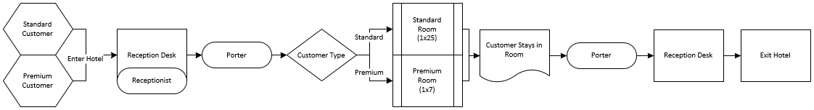

The diagram below shows the process for housekeepers, which is the ‘on-demand housekeeper’ simulation:

On-Demand Housekeeper:

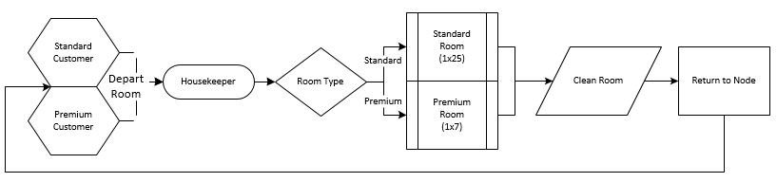

As seen in the diagrams, guests enter the hotel and are greeted by the receptionist. There are three receptionists, and when all three are busy the guests will wait in a queue. After check-in, guests are escorted by the porter to their room (the first available room for their type). As guests depart, they are escorted back to the counter to check-out, before they exit. A condition not seen in the diagram is that the room must be clean before the guest can stay in it, which is assumed rather than displayed in the diagram.

For housekeepers, their job is to clean the vacant rooms which must be cleaned after one guest occupies it before another guest can stay in it. For on-demand housekeepers, they are notified when a guest departs the room and they walk over to the room to begin cleaning. This ‘cleaning’ is solved in Simio using a seize room and seize housekeeper process (moving the housekeeper to the room node), followed by a delay of time for the ‘cleaning’ duration, and the a release for the room and housekeeper.

## Random Time Estimates Used

Along with taking some of the previous research in this topic as a practical guide, random estimates for the following items are built into the model:

* Incoming Guests Entry Times [4]
  + Triangular, min=7, mode=15, max=28 (minutes)
  + Probability of Premium Guest: 15%
  + Guests per Arrival: Triangular, min=1, mode=2, max=3 (guests)
* Reception
  + Check-In [5]: Triangular, min=4, mode=6, max=14 (minutes)
  + Check-Out: 0 (minutes)
* Guest Stay Durations: Uniform, m in=6, max=10 (hours)
* Room Cleaning Times [5]
  + Standard Rooms: Triangular, min=5, mode=14.6, max=28 (minutes)
  + Premium Rooms: Standard Rooms + 3 (minutes)
* Porter speed [5]: Lognormal, normal mean=0.927, normal standard deviation=0.264 (meters per minute, with each path being 1 meter)

## Costs and Revenues Used

Costs used in the model include:

* Staff wages [6]
  + Receptionists: $10.55 per hour
  + Porters: $10.74 per hour
  + Housekeepers: $10.16 per hour
* Room Fixed Costs*: $425 per room per day
  + Room Fixed Costs were moved upwards from $250 after high-level maximum and minimum profit calculations, so that minimum profit would realize a loss instead of a profit.

Revenues used in the model include:

* Standard Room: $150 per guest
* Premium Room: $250 per guest

## Staff Scheduling Used

Staff schedules are incredibly important to this model and the initial schedule includes:

* Receptionists: 3 shifts of receptionists, no lunch breaks (to simplify the model)
  + Shift 1: 12:00am – 8:00am, 2 receptionists
  + Shift 2: 8:00am – 4:00pm, 3 receptionists
  + Shift 3: 4:00pm – 12:00am, 3 receptionists
* Porters**: 3 shifts of porters, no lunch breaks (to simplify the model)
  + Shift 1: 4:00am – 12:00pm, 1 porter
  + Shift 2: 12:00pm – 8:00pm, 1 porter
  + Shift 3: 8:00pm – 4:00am, 1 porter
* Housekeepers**: 3 shifts of housekeepers, no lunch breaks (to simplify the model)
  + Shift 1: 6:00am – 2:00pm, 1 housekeepers
  + Shift 2: 2:00pm – 10:00pm, 1 housekeepers
  + Shift 3: 10:00pm – 6:00am, 1 housekeepers
* ** After troubles with the simulation model and tweaking of resource costs/revenues, the model is simplified to one housekeeper/porter per shift (one housekeeper/porter total in the model).

# Verification and Validation

## Min/Max Profit Range

One method of verification is to calculate the minimum and maximum expected profits to ensure that our realized profits fall within the range; if our results fall outside of the range then there is an issue somewhere in the model that needs to be fixed.

The calculation of our minimum and maximum profit is in the accompanying RMarkdown file. The results of the calculation are an expected cost of $14,776.80, a maximum potential profit of $6,803.58, and a minimum potential profit (loss) of ($2,740.33).

## Verification Checks

As mentioned before, numerous hours have been spent on research, so to not let that knowledge go to waste I consider suggestions from resources more in tuned with simulation modeling that myself [8]. Some of these resources have fancy graphs [9], or figures [10], but here I simply want to get a high-level idea of what’s involved what is possible to achieve in this project.

One method suggested is general good programming practice, I will assume that I achieve this. Other methods suggested include checking of intermediate simulation outputs through tracing and statistical testing per module, comparing final simulation outputs with analytical results, and animation. In the creation of the Simio model: animation will be used, a statistical (analytical) method will be used as a comparison with the simulation model, and the statistical analysis will include a comparison for each functional type of service (i.e. reception, room stays, etc.). By following this guide, verification

## Validation Checks

Validation of the model is a different story. Validating that the simulation model accurately reflects that of a real world representation, in this particular case, would likely be done empirically. Since I don’t have access to the financials of a hotel, or a hotel with the particular parameters I’ve set, I decided to skip this type of validation and refer to other methods.

Non-empirical methods include simple tests for comparing simulated and real data (which is really a hybrid form of empirical), regression analysis for comparisons between simulation and real responses (another form of empirical), sensitivity analysis and risk analysis, and white and black box simulations. In this form, white and black box simulations refers to common sense (white box) and prediction as opposed to explanation (black box). Our statistical model will include Monte Carlo simulations which is a sensitivity and risk analysis, while our animation and intuition in the simulation model will give us insight into our common sense and intuition; thus, fulfilling our validation checks.

# Statistical Model

A poorly crafted statistical model has been created in R.

# Simulation Models

## Model 1: On-Demand Housekeeping

The diagram below shows the initial facility view structure of our simulation model in both 2D and 3D views:

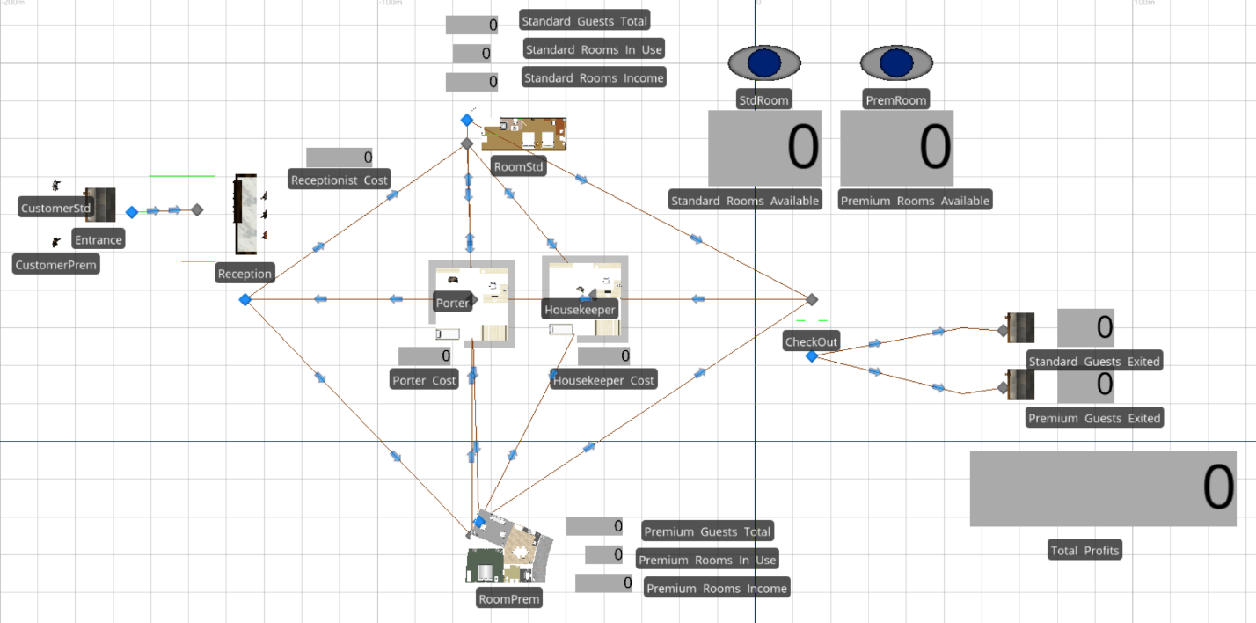

3D View:

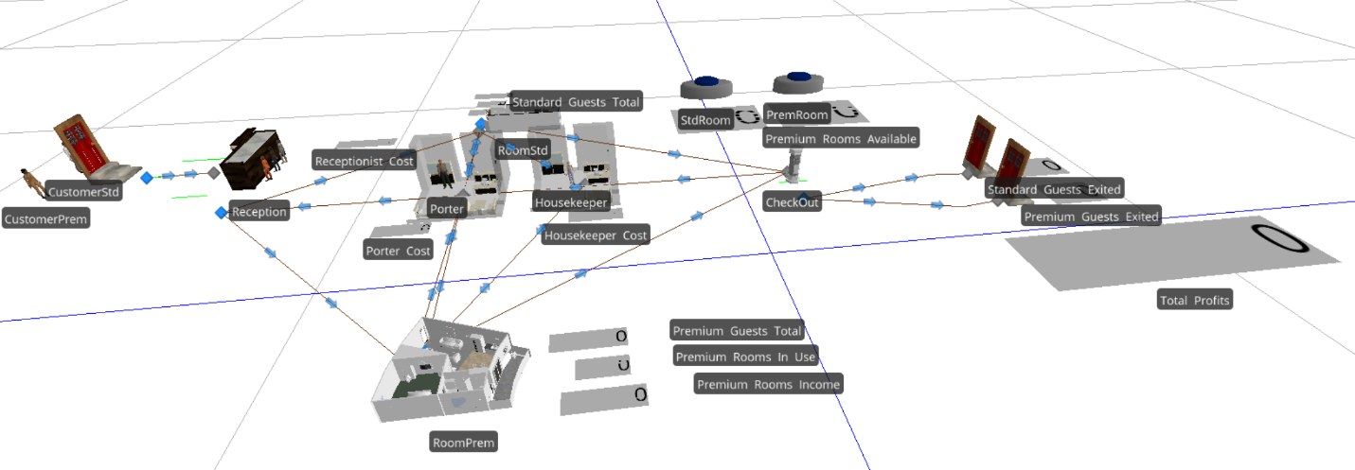

The results of our simulation:

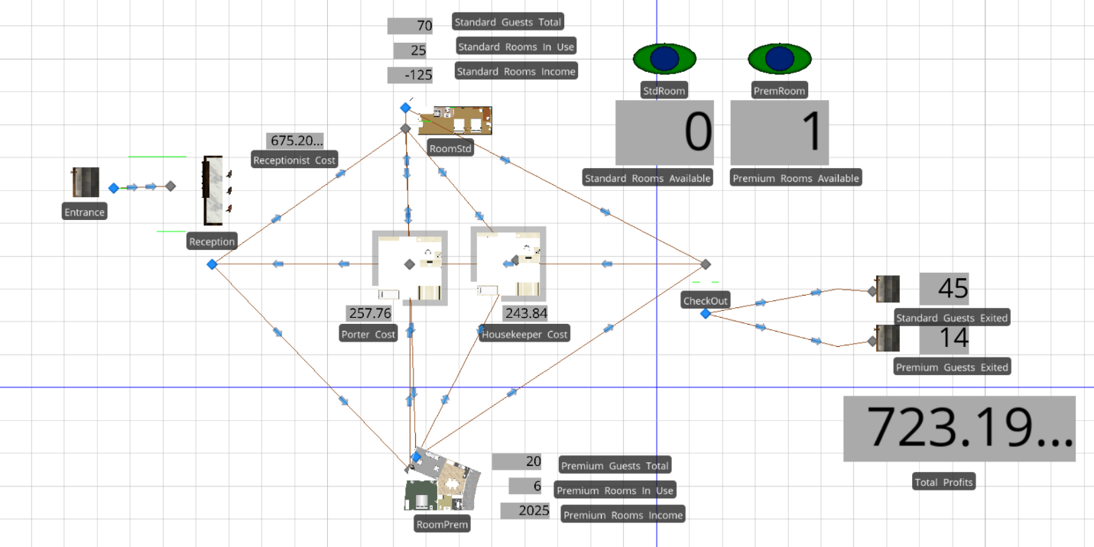

After running the simulation for a 24-hour period, our hotel managed to squeak out a tiny profit of $723.19. After performing some sensitivity analysis, it appears that premium rooms are a key driver since changing the mix from 15% probability of a premium guest to 10% results in 4 premium rooms being available at the end of the 24-hour period, a loss of ($276.80), and premium room revenue of $625 as opposed to a loss of ($125).

Results of the changed mix:

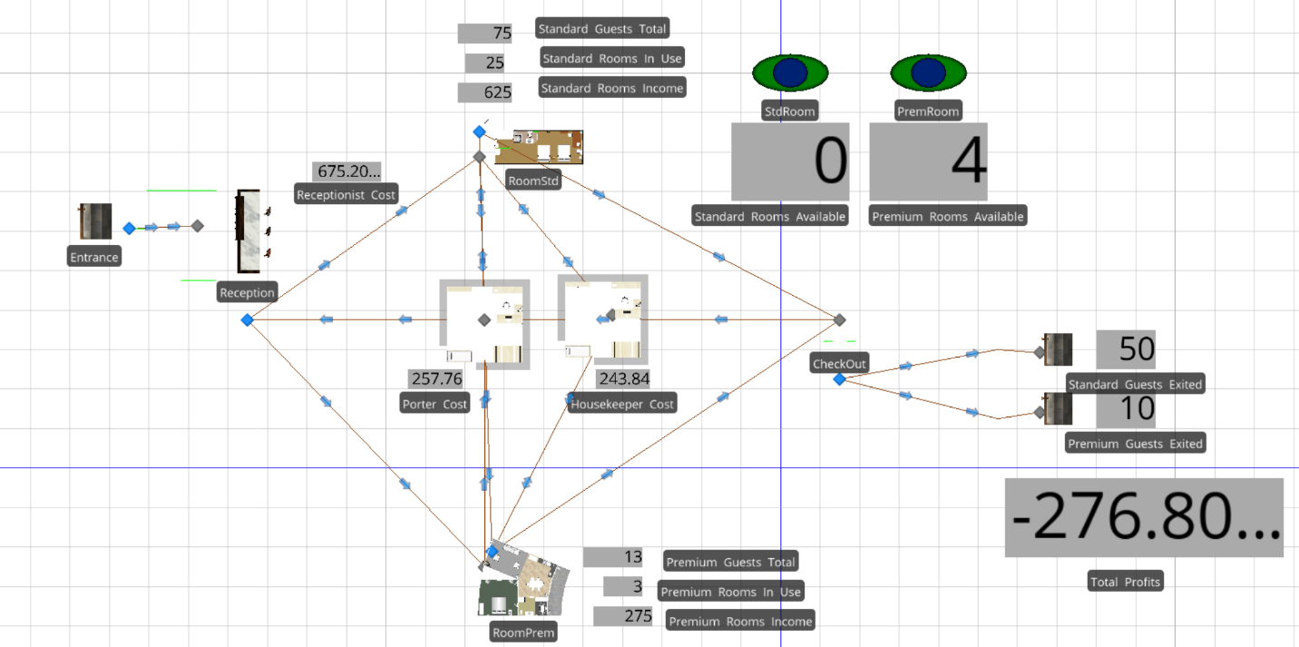

One note is that the number of standard guests that checked into a room in our model was 70, while the number of premium guests checked in was 20. This means that 26.57% of the checked-in guests were premium guests, significantly higher than our parameters of 15% mix. This could indicate an error in the model, but when debugging through step-wise evaluation and monitoring, I did not find one. After changing the mix to 10% premium guests (which resulted in a model mix of 17.33% premium guests), there was a resource error in that model entities were carrying resources after being destroyed. Debugging could not fix this either.

## Model 2: Multi-tasking Receptionists + 3 Housekeepers / Adjusted Model

The diagram below shows the initial facility view structure of our simulation model in both 2D and 3D views:

2D View:

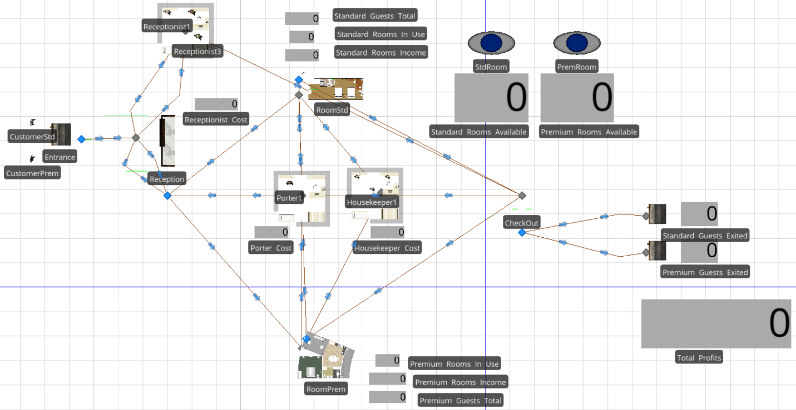

3D View:

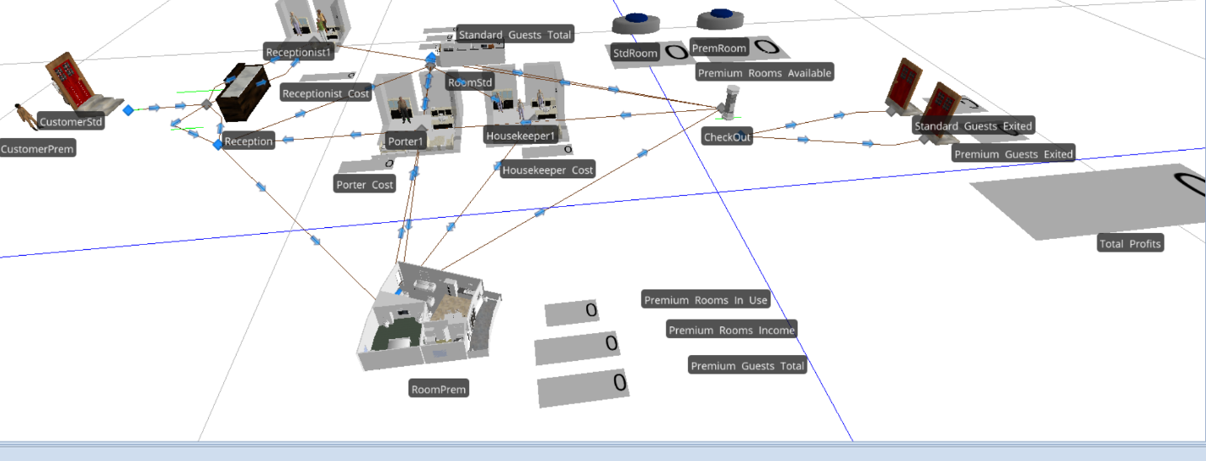

Results of the simulation:

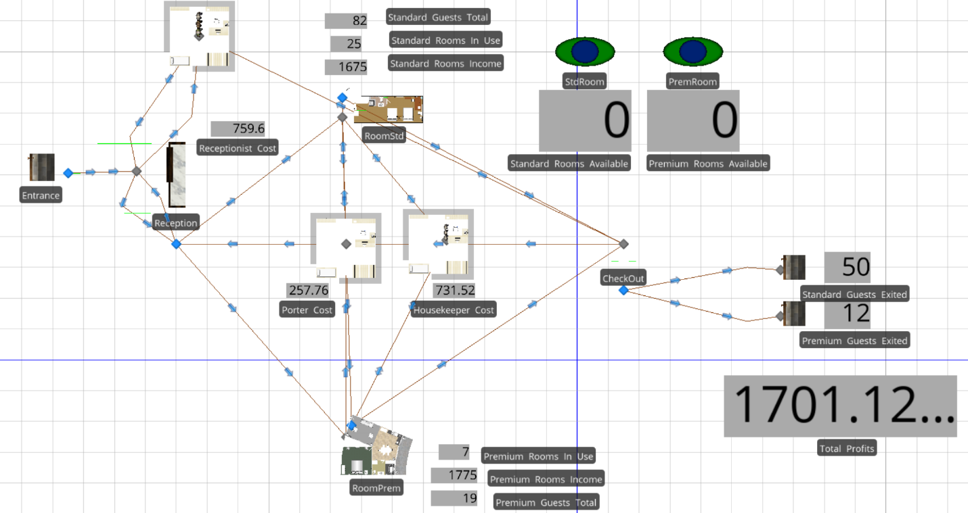

Surprisingly, the profit margin greatly increased with this adjustment. It appears that there is a significant delay for some guests moving to and from rooms when relying on a single escort, and housekeepers play a significant role in the room availability.

## Model 3: On-Demand Housekeeping * 3 / Adjusted Model

To keep consistency in my models, I decided to re-do the first model (On-Demand Housekeeping) with the new model set-up from Model 2 (Multi-Tasking Receptionists) – simply put, three housekeepers would clean and the three receptionist would perform one task (check-in) but move to their staff room when idle, and porters would perform the sole task of escorting guests to and from rooms.

Results of the adjusted model:

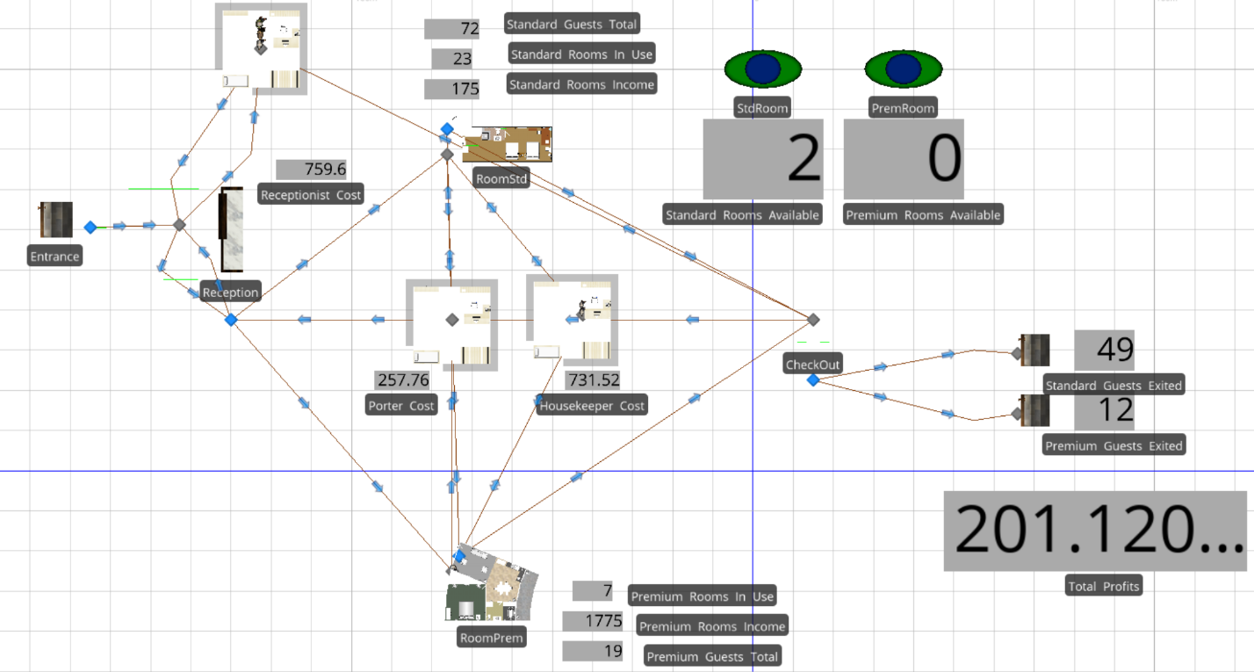

Results from this simple adjustment are interesting. Rather than the first profit of $723.10 (Model 1), Model 3 achieved a smaller profit of $201.12 and the premium guest mix was 9.72%. I think I am more surprised that the mix was changed so dramatically, while I’m not surprised by the profit shift since premium guests made up such a small mix and expenses increased with more housekeepers.

# Comparison of Results via Statistical Methods

|  |  |  |  |  |
| --- | --- | --- | --- | --- |
| **Model** | **Statistical** | **Model 1** | **Model 2** | **Model 3** |
| Profit | Est.: $1,723.20 ?  Min: ($2,740.33)  Max: $6,803.58 | $723.19 | $1,701.12 | $201.12 |
| Standard Guests | 85 (?) | 70 | 82 | 72 |
| Premium Guests | 15 (?) | 20 | 19 | 19 |
| Housekeeper Utilization | 54% (?) | 62% | 22%  (8% + 20% + 38%) | 20%  (8% + 16% + 37%) |
| ~~Receptionist Utilization*~~ | ~~NA~~ | ~~N/A~~ | ~~<1%~~  ~~(1% + 0.15% + 0%)~~ | ~~(0% + 0% + 0%)~~ |
| Reception Utilization | 1% (?)  (can’t be right)­­­­­­ | 68% | 57% | 57% |
| Porter Utilization | 10% (?) | 8% | 7% | 8% |

*Receptionist Utilization does not work in these models, likely because they are created as process seizes rather than resource requirements for the server (Model 2 and Model 3) or because it is the server itself ‘performing’ the work according to Simio (Model 1).

# Conclusions from the Modeling

Model 2 is clearly the most efficient and most effective simulation, and a recommendation could be made that housekeepers (though not always ‘working’) are essential to the hotel running efficiently and that receptionists can be cross-trained to perform duties as Porters, but there are likely outside benefits of having Porters separately (hotel image and reputation being a metric difficult to assess, and nearly impossible to simulate in this model).

# Lessons Learned

Simio has many powerful tools, though they can be difficult to navigate and it take some getting used to. My model used them all including a mix of processes, schedules, state variables, entity priorities, etc. Seizing capacity from resources and servers, while destroying the entities (guests), which I tried to do to assign housekeepers to clean a room after check-out, was a main bottleneck faced in the model. By using a process upon entity leaving the room to delay the use of the room was my model’s work-around, showing me that there’s always more than one way to achieving the goal.

In terms of optimization and model set-up, keeping a simple layout was more important that I realized. When first creating the model, I had 25 standard room and 7 premium room symbols. This proved incredibly cumbersome to navigate and required me to create more processes than I wanted to. After taking some time to simplify the model and generalize processes, my model seemed to run much more smoothly and I was able to add other interesting add-ons such as state variables which led to live counters being available to use on the model.

A special note has to be made in that I tried to use a transfer node to connect housekeeper and porter routes to the rooms and simplify the model even more, but there is a bug in the Simio software that keeps transporters in the transfer node, preventing them from being used again. I had to start over, and re-do the paths.

Finally, as makeshift as our statistical model was, it turned out to be quite similar to our optimal simulation model in terms of profitability. I don’t trust the utilization estimates, at all.

# Additional Resources

|  |  |  |
| --- | --- | --- |
| **Resource Name** | **Description** | **Link** |
| GitHub Folder | GitHub folder including models, R code, images, and this document. | https://github.com/chrisgmartin/DATA604-Final |
| Statistical Model Support | RPubs website hosting the support for the Statistical Model | http://rpubs.com/chrisgmartin/data604_final_statmodel |
| Video Recording (Model Walkthrough) | YouTube video presentation and model walkthrough | https://www.youtube.com/edit?o=U&video_id=EbHdsl6CdeU |
| PowerPoint Presentation | PowerPoint slide deck created in R | https://github.com/chrisgmartin/DATA604-Final/blob/master/Simulation%20Analysis%20-%20Presentation.pptx |

# References

1. Thompson, G. M. (2003). Computer Simulation in Hospitality Teaching, Practice, and Research. Cornell University School of Hotel Administration The Scholarly Commons, Quarterly, 44(2), 85-93. <http://scholarship.sha.cornell.edu/cgi/viewcontent.cgi?article=1055&context=articles>
2. Feinstein, A., & Parks, S. J. (2002). Simulation Resarch in the Hospitality Industry. Developments in Business Simulation and Experiential Learning, Volume 29, 2002, 45-57. <https://journals.tdl.org/absel/index.php/absel/article/viewFile/748/717>
3. Edelheim, J., & Ueda, D. (2007). Effective Use of Simulations in Hospitality Management Education a Case Study. Journal of Hospitality, Leisure, ,Sport & Tourism Education, Vol. 6, No. 1, 18-28. <http://www.academia.edu/1163538/Effective_Use_of_Simulations_in_Hospitality_Management_Education_a_Case_Study>
4. Thompson, G. M. (1999, June). Labor scheduling, Part 4. The Cornell Hotel and Restaurant Administration Quarterly, 40(3), 85-97. <http://scholarship.sha.cornell.edu/cgi/viewcontent.cgi?article=1749&context=articles>
5. Malony, R. J. (2011). Analysis of Staff Scheduling Effect on Hospitality Staffing Service Efficiency During High-Occupancy Conditions Using Discrete Event Simulation (DES). Embry Riddle Aeronautical University Scholarly Commons, Dissertations and Theses, Paper 99. <https://commons.erau.edu/cgi/viewcontent.cgi?article=1098&context=edt>
6. Salary Estimates: <https://www.payscale.com/research/US/Job=Housekeeper/Hourly_Rate>
7. Dominguez, A. E. (1993). The Hotel Management Simulation / Game: An Evaluation of Game Mechanics and Learning Outcomes. Rochester Institute of Technology RIT Scholar Works, Thesis Dissertations Collection. <http://scholarworks.rit.edu/cgi/viewcontent.cgi?article=8197&context=theses>
8. Kleijnen, J. P. C. (1992). Theory and Methodology: Verification and Validation of Simulation Models. European Journal of Operational Research 82 (1995), 145-162. <http://faculty.kfupm.edu.sa/ics/salah/misc/courses/ics533/slides/Kleijnen1995.pdf>
9. Sargent, R. G. (1996). Verification and Validation of Simulation Models. Syraacuse University, College of Engineering and Computer Science, Department of Electrical Engineering and Computer Sciencce, Simulation Rearch Group. <https://surface.syr.edu/cgi/viewcontent.cgi?referer=https://scholar.google.com/&httpsredir=1&article=1006&context=eecs>
10. (Note, this is a different paper than above, though very similar)S argent, R. G. (2013) .Verification and Validation of Simulation Models. Journal of Simulation, 7, 12-24. <https://pdfs.semanticscholar.org/9917/5990a45f646a8c5e2a47137beb0837bb5a50.pdf>

# Final Project Prompt

In groups of 1 to 3, I want you to pick a real-world system or process and model it using either JaamSim or Simio. No other software is authorized. Choose something of interest to the group, and be sure it is sufficiently complex to require simulation techniques. (If it is analytically tractable using any other method, then you should not use simulation.) Model the system as completely as necessary, conduct verification, and validation, and provide the appropriate statistics for variables of interest. Be sure you use random number streams and other methods we have discussed in the course! Then, model an alternative to the system / process (interventional model). Again, gather statistics for variables of interest. Compare the performance of the two models statistically. Then, prepare the following.

1. 5-page (minimum) final paper (double-spaced, 12" Arial, 1" margins, not including graphs, cover pages, references). The paper must include the following.
   1. Background, purpose, significance
   2. 5 peer-reviewed literature pieces discussing similar models (must be peer-reviewed journals)
   3. Structure / process diagram
   4. Flowcharts for modeling
   5. Verification & Validation methods
   6. Results of status quo and interventional model
   7. Comparison of results via statistical methods
   8. Conclusions from the modeling
   9. What you learned
2. Models for both simulations (status quo and interventional)
3. 10-slide PowerPoint discussion of models with either speaker notes or audio walk-through